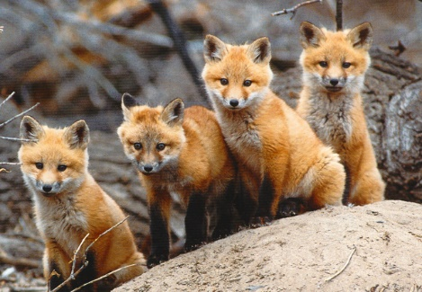
LITTLE FOXES NURSERY
Emma 01453 757251
littlefoxespreschool@foxmoor.gloucs.sch.uk
PLEASE DO NOT PARK IN THE SCHOOL CARPARK IT IS FOR STAFF ONLY THANKYOU
NO DOGS ON SITE PLEASE
Dates for your Diary
February Half term
Break up on Friday 13th February and back on Monday 23rd February.
Easter Holidays
Break up on Friday 27th March and back on Monday 13th April.
Information board
We are going to try and trial putting our daily routine on Tapestry instead of doing the white board every day.

Little Foxes Newsletter
January 2026
Welcome back everyone thanks for all your continued support.
We would also like to welcome all the new families that have joined us this term.
Welcome to little Foxes.

FOXES N

Lunchboxes

PLEASE cut your child’s grapes in half to prevent choking.
Also due to allergies we are a NUT FREE environment.
Also please send a healthy lunchbox and water in their bottles please.
No sweets or excessive Chocolate.

THEMES
Transport
Chinese New Year

Reminder- PLEASE Make sure your children’s things are labelled
PLEASE can you remember your children’s folder each day as we pop all their colourings and notes in them. Thankyou.

Cattle Country
The children enjoyed a lovely trip to Cattle Country where they all took a ride on the train to see Father Christmas. Along with the usual play barn fun, they also got to see a real reindeer!

`

Themes/Festivals we will be covering this term
Winter Arctic animals Maths number 3
Chinese new year Valentines Pancake day
Growing/planting Mother’s day Spring
Farm animals Easter Music Life cycles
The hungry caterpillar Patterns Shapes
Healthy eating
--------------------------------------------------------------
PLEASE be on time picking your child up, we understand the odd time but when its continuous we will charge a late fee.
THANKYOU FOR YOUR CONTINUED SUPPORT
Little Foxes Team

.

DONATION- Due to rising costs we would be very grateful if any parents/carers could make a small donation each week (we suggest £1 a week) to help contribute to our fruit and snack costs.
We will have a donation box just inside Little Foxes tunnel. Thankyou x

Coming into Nursery
Now we have got into a routine of opening the gate for the children in the mornings, If your child feels confident and is happy to walk in by themselves then they are more than welcome to walk down with me.
Tapestry- Please log on and look at your child’s profile, we spend lots of time putting photos and observations on for you to see, also you can put photos on for us to see.

